Next generation sequencing variant view snapshot of the variants identified in the patients using StrandOmics v5.0 software.
Patient P₁
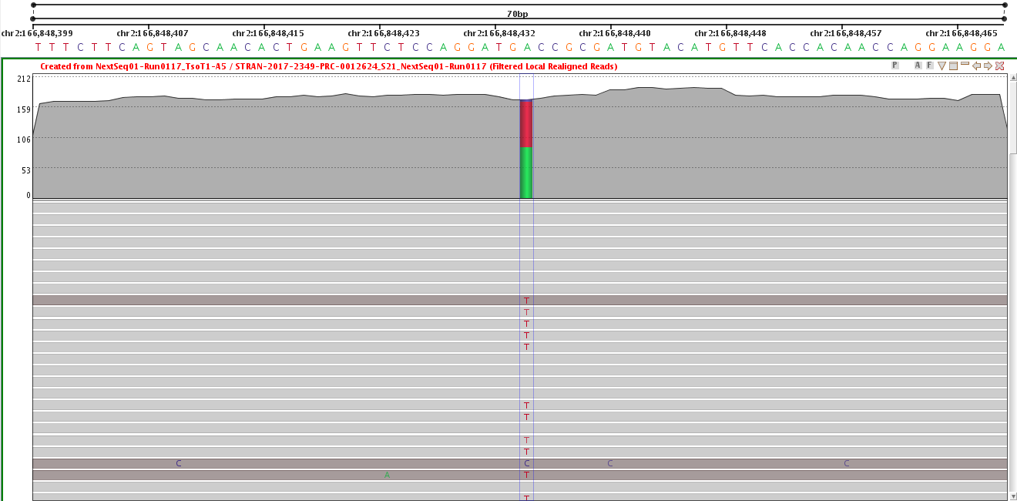

Snapshot P₁: Patient P₁ was found heterozygous for c.5351T>A (p.Val1784Asp) variant in exon 26 of SCN1A gene that resulted in an autosomal dominantly inherited Early Infantile Epileptic Encephalopathy-6 (EIEE6; Dravet syndrome).

Patient P₂
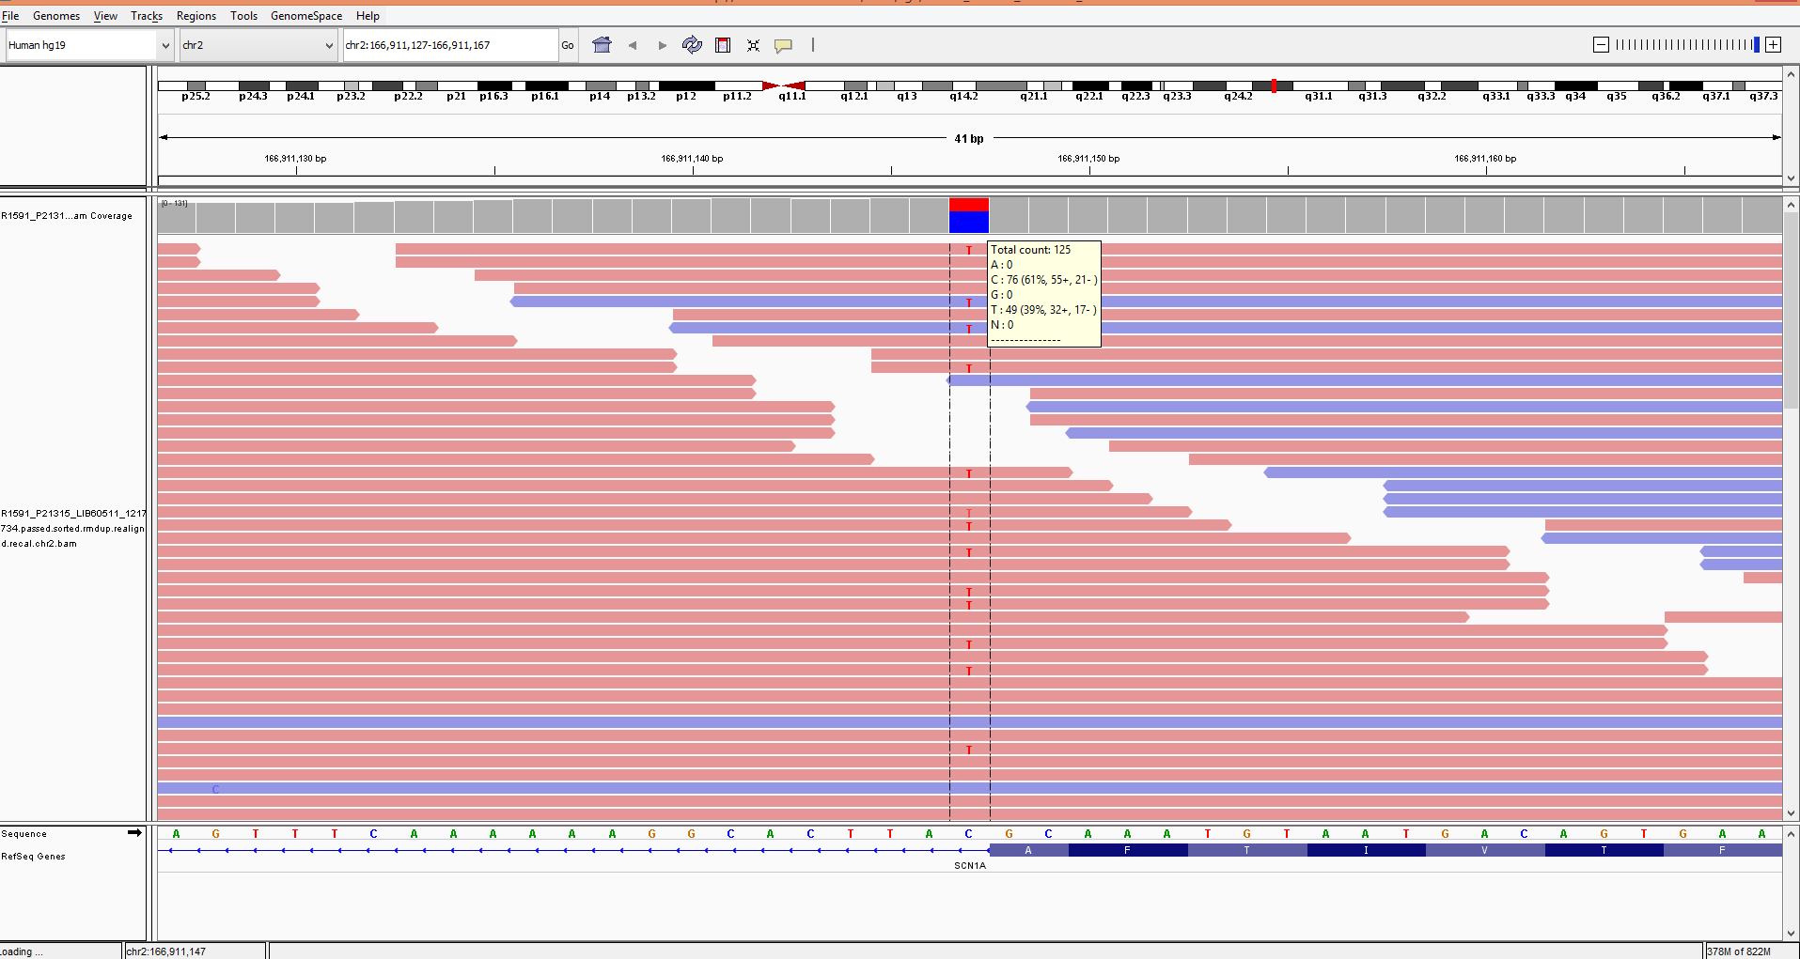

Snapshot P₂: Patient P₂ was found heterozygous for c.602+1G>A (5’ splice site) variant in intron 4 of SCN1A gene that resulted in an autosomal dominantly inherited Early Infantile Epileptic Encephalopathy-6 (EIEE6; Dravet syndrome).

Patient P₃
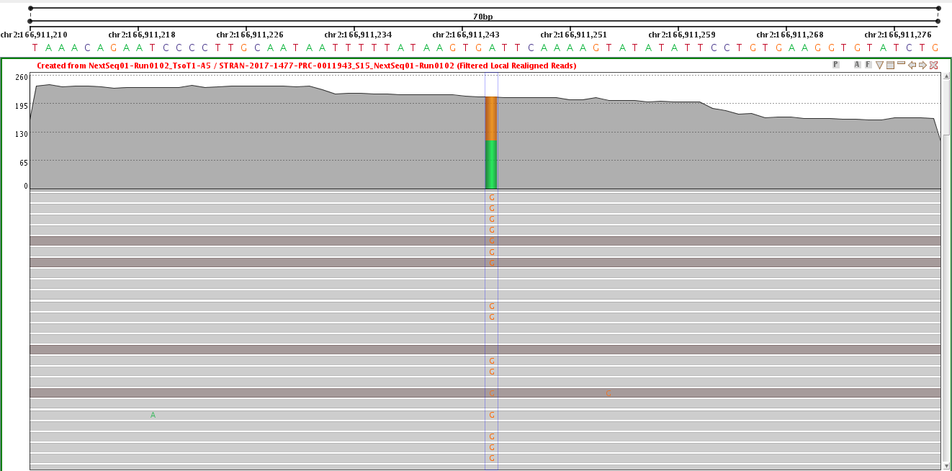

Snapshot P₃: Patient P₃ was found heterozygous for c.505T>C (p.Ser169Pro) variant in exon 4 of SCN1A gene that resulted in an autosomal dominantly inherited Early Infantile Epileptic Encephalopathy-6 (EIEE6; Dravet syndrome).

Patient P₄
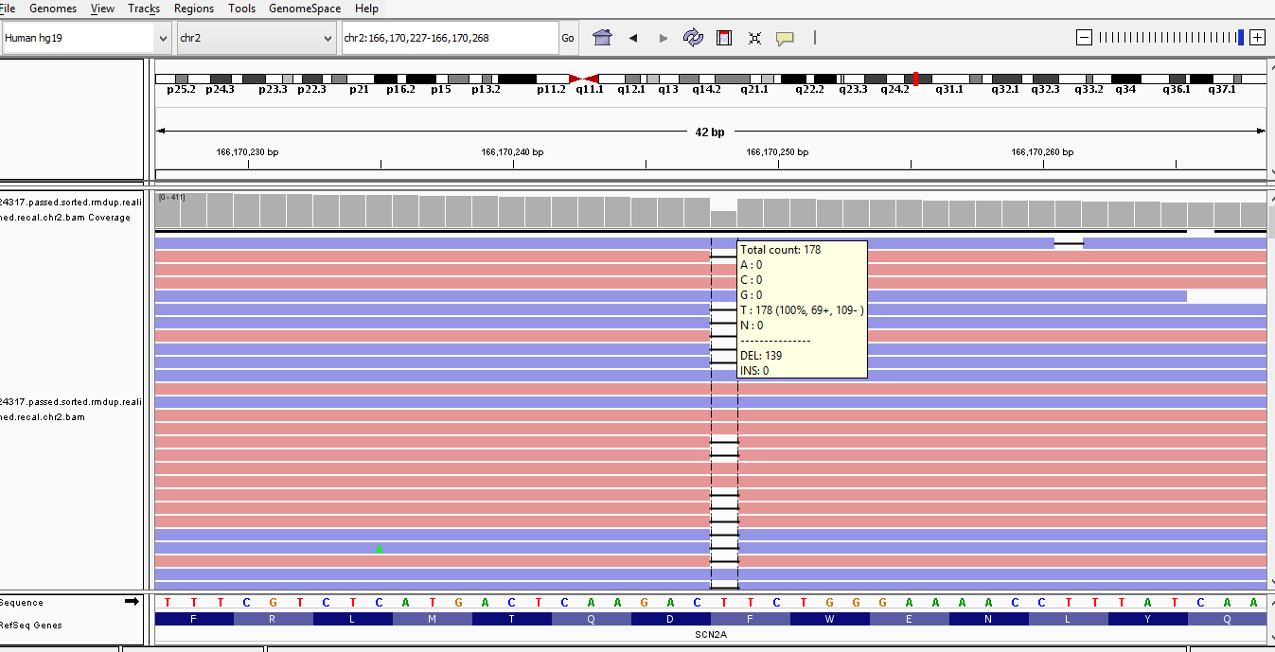

Snapshot P₄: Patient P₄ was found heterozygous for c.1153delT (p.Phe385SerfsTer8) variant in exon 9 of SCN2A gene which resulted in an autosomal dominantly inherited Early Infantile Epileptic Encephalopathy-11 (EIEE11) disorder.

Patient P₆
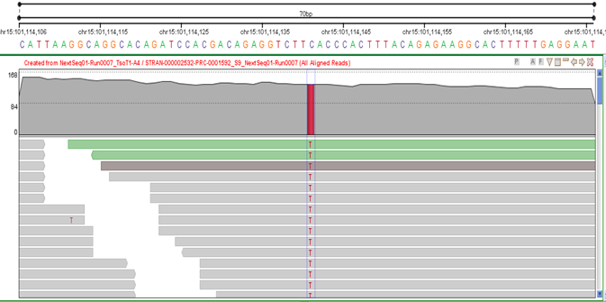

Snapshot P₆: Patient P₆ was found homozygous for c.937G>A (p.Glu313Lys) variant in exon 5 of LINS1 gene which resulted in an autosomal recessively inherited Mental Retardation-27 (MRT27).

Patient P₇
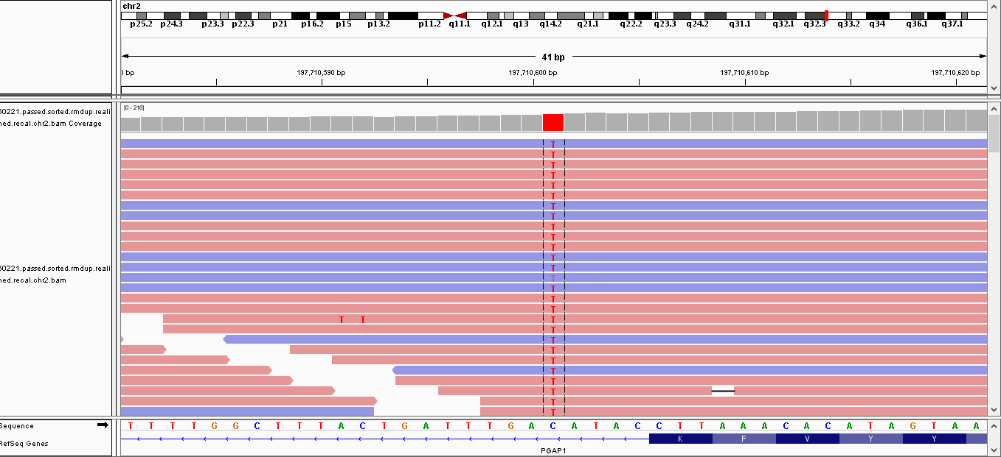

Snapshot P₇: Patient P₇ was found homozygous for c.2286+5G>A (5' splice site) variant in intron 23 of PGAP1 gene which resulted in an autosomal recessively inherited Mental Retardation-42 (MRT42).

Patient P₈
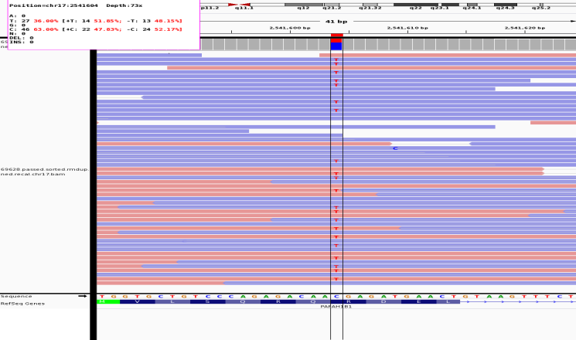

Snapshot P₈: Patient P₈ was found heterozygous for c.22C>T (p.Arg8Thr) variant in exon 2 of PAFAH1B1 gene which resulted in an autosomal dominantly inherited Lissencephaly 1 (LIS1).

Patient P₁₀ (Variant 1)
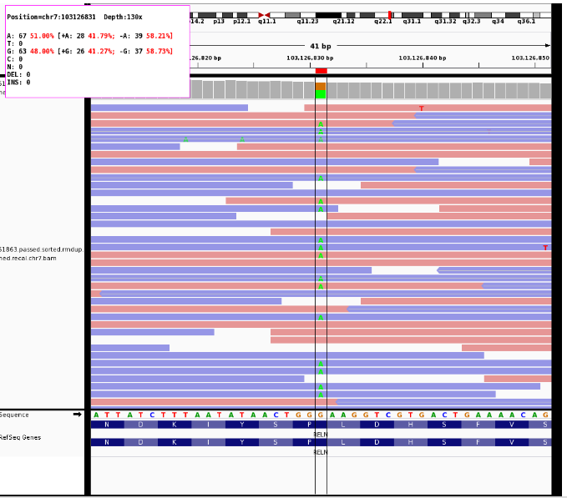

Snapshot P₁₀ (1): Patient P₁₀ carried compound homozygous variants which resulted in an autosomal recessively inherited Lissencephaly-2 (LIS2). Variant 1, c.9796C>T (p.Pro3266Ser), was found in exon 25 of RELN gene.

Patient P₁₀ (Variant 2)
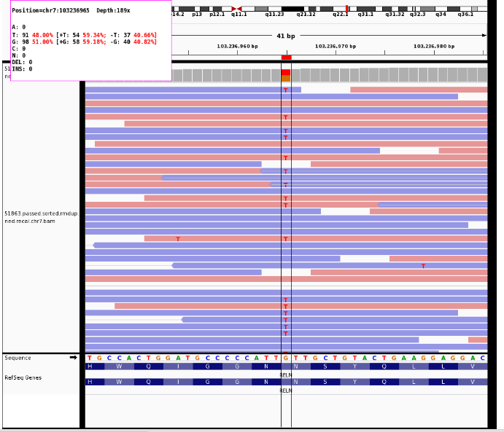

Snapshot P₁₀ (2): Patient P₁₀ carried compound homozygous variants which resulted in an autosomal recessively inherited Lissencephaly-2 (LIS2). Variant 2, c.3477C>A (p.Asn1159Lys), was found in exon 25 of RELN gene.

Patient P₁₁
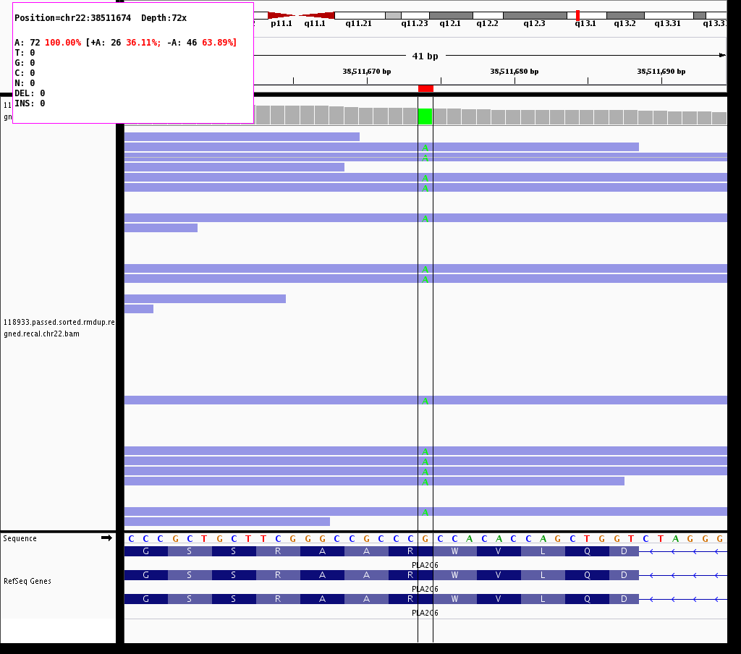

Snapshot P₁₁: Patient P₁₁ was found homozygous for c.1894C>T (p.Arg632Trp) variant in exon 14 of PLA2G6 gene which resulted in an autosomal recessively inherited Parkinson disease-14 (PARK14).

Patient P₁₂ (Variant 1)

Snapshot P₁₂ (1): Patient P₁₂ carried compound homozygous variants which resulted in an autosomal recessively inherited Parkinson disease-15 (PARK15). Variant 1, c.274G>C (p.Asp92His), was found in exon 2 of FBXO7 gene.

Patient P₁₂ (Variant 2)

Snapshot P₁₂ (2): Patient P₁₂ carried compound homozygous variants which resulted in an autosomal recessively inherited Parkinson disease-15 (PARK15). Variant 2, c.520T>A (p.Set174Thr), was found in exon 3 of FBXO7 gene.

Patient P₁₃
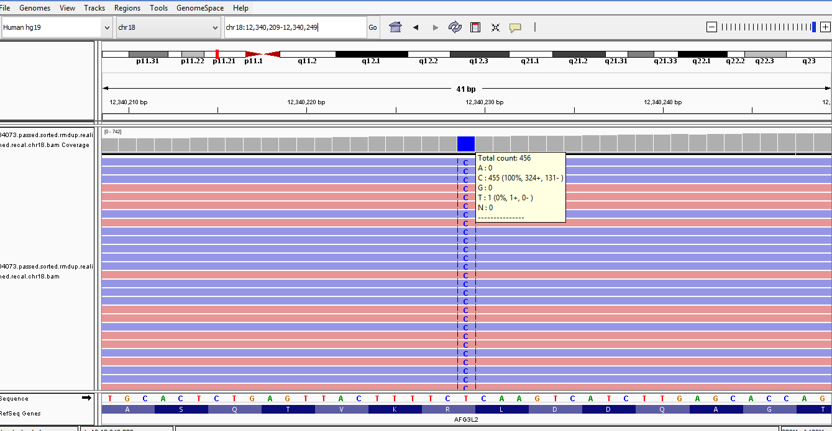

Snapshot P₁₃: Patient P₁₃ was found homozygous for c.1951A>G (p.Arg651Gly) variant in exon 15 of AFG3L2 gene which resulted in an autosomal recessively inherited spastic ataxia-5 (SPAX5).

Patient P₁₄
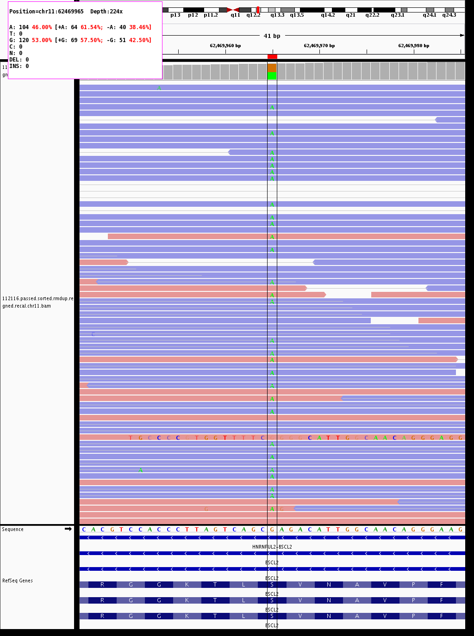

Snapshot P₁₄: Patient P₁₄ was found heterozygous for c.461C>T (p.Ser154Leu) variant in exon 4 of BSCL2 gene which resulted in an autosomal dominantly inherited spastic paraplegia (SPG17).

Patient P₁₅
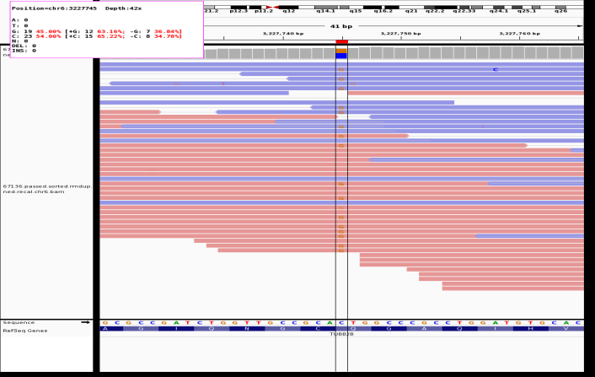

Snapshot P₁₅: Patient P₁₅ was found heterozygous for c. 33G>C (p.Gln11His) variant in exon 1 of TUBB2B gene which resulted in an autosomal dominantly inherited complex cortical dysplasia with other brain malformations-7 (CDCBM7).

Patient P₁₇
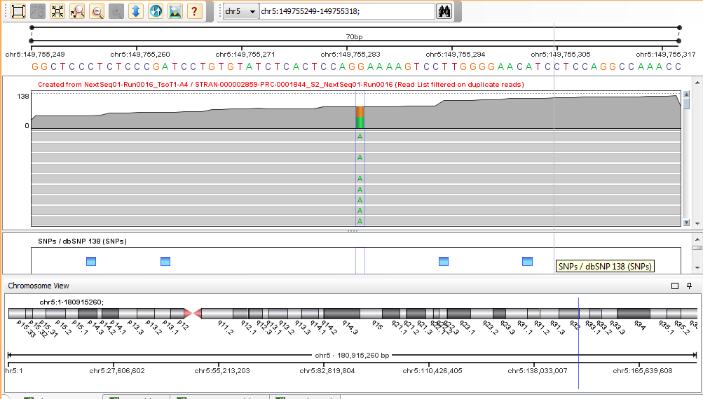

Snapshot P₁₇: Patient P₁₇ was found heterozygous for c.1705G>A(p.Glu569Lys) variant in exon 12 of TCOF1 gene which resulted in an autosomal dominantly inherited Treacher Collins syndrome 1 (TCS1).

Patient P₁₈
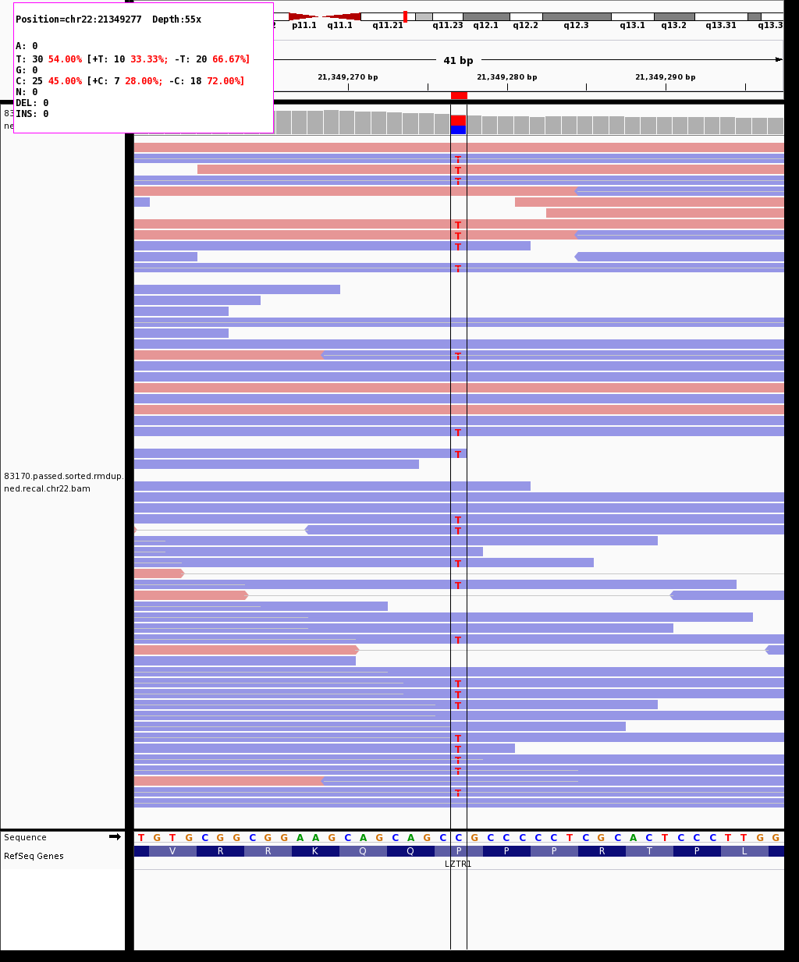

Snapshot P₁₈: Patient P₁₈ was found heterozygous for c.1904C>T (p.Pro635Leu) variant in exon 16 of LZTR1 gene which resulted in an autosomal dominantly inherited Noonan syndrome-10 (NS10).

